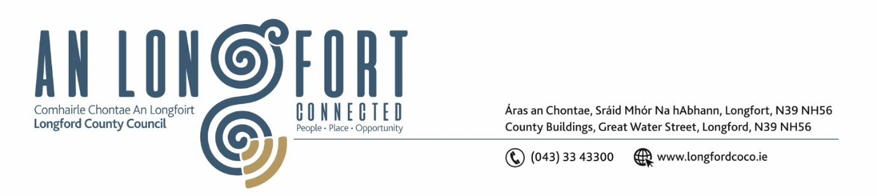

**LONGFORD MUNICIPAL DISTRICT**

**Minutes of Meeting of Longford Municipal District**

**held in the Council Chamber Aras an Chontae and via MS Teams**

**on Wednesday, 24 April 2024 at 10am**

**CATHAOIRLEACH**: Councillor Martin Monaghan

**MEMBERS PRESENT**: Councillors Peggy Nolan, Uruemu Adejinmi, Gerry Hagan, Gerry Warnock, John Browne

**IN ATTENDANCE**: Mr. Michael Nevin, Director of Services

Mr. David McNiff, A/Senior Executive Engineer

Ms. Helena Heaney

**MEETINGS**

**ADMINISTRATOR:**  Ms. Claire McNabola

**APOLOGIES:** None

1. **ADOPTION OF MINUTES – circulated**
2. On the proposal of Councillor Peggy Nolan seconded by Councillor Gerry Warnock it was unanimously agreed to adopt Minutes of Committee Meeting of Longford Municipal District held on Wednesday, 27 March 2024 as circulated.
3. On the proposal of Councillor Gerry Warnock seconded by Councillor Peggy Nolan it was unanimously agreed to adopt Minutes of Meeting of Longford Municipal District held on Wednesday, 27 March 2024 as circulated.
4. **MATTERS ARISING FROM MINUTES**

Councillor Uruemu Adejinmi requested an amendment to the minutes - Notice of Motion number (ii) at the March meeting was proposed by Councillor Uruemu Adejinmi and seconded by Councillor Seamus Butler

1. **DECLARATION OF INTEREST BY MEMBERS**

None

1. **MANAGEMENT REPORT – as circulated**

The Management Report, as circulated, was noted.

The Members requested that a member of the Active Travel Team attend the next meeting of Longford MD and update them in the ongoing works on the Battery Road and plans to alleviate traffic coming into the summer months.

1. **WOMEN’S REGIONAL CAUCUS SAFETY WALKING AUDIT REPORT**

Noted

Councillor Uruemu Adejinmi thanked the Members of the Public for their support while the Safety Walking Audit was taking place. Cllr Adejinmi also thanked those who carried out the Audit and to the Regional Women’s Caucus for all their support.

1. **CORRESPONDENCE**

Response received from Irish Water

Noted

1. **GENERAL**

**NOTICE OF MOTION SET OUT HEREUNDER**

**The following Notice of Motion was proposed by Councillor Uruemu Adejinmi and Councillor Seamus Butler, seconded by Councillor Martin Monaghan**

We are calling on Longford County Council to examine the feasibility of installing a columbarium wall facility in a suitable Clondra/ Killashee district graveyard where cremated remains can be immured, allowing people’s remains to be laid to rest in the locality.

**Response**

Longford County Council installed a county columbarium wall in Ballymacormack Cemetery in early 2022. The freestanding wall contains 40 niches, each with capacity to hold a double urn. To date 7 of the niches have been utilised. Longford County Council have no plans for a second columbarium wall in the county at this time. Urns can be buried in a single plot in any graveyard, either on their own or in combination with up to 2 coffins.”

Councillor Nolan & Councillor Monaghan both support the motion and added that the proposed site in Clondra is a Heritage Site and therefore isn’t suitable. A suitable site would have to be identified before any plans could be progressed.

This concluded the business of the meeting.

**Signed: ____________________**

**Claire McNabola,**

**Meetings Administrator.**

**Confirmed and adopted at Longford Municipal District Meeting held on the 22 May 2024.**

**Signed: _______________**

**Cathaoirleach**